Using the SOCIO Chatbot for UML Modelling: A Family of Experiments
Abstract:
Context: Recent developments in natural language processing have facilitated the adoption of chatbots in typically collaborative software engineering tasks (such as diagram modelling). Families of experiments can assess the performance of tools and processes and, at the same time, alleviate some of the typical shortcomings of individual experiments (e.g., inaccurate and potentially biased results due to a small number of participants). Objective: Compare the usability of a chatbot for collaborative modelling (i.e., SOCIO) and an online web tool (i.e., Creately). Method: We conducted a family of three experiments to evaluate the usability of SOCIO against the Creately online collaborative tool in academic settings. Results: The student participants were faster at building class diagrams using the chatbot than with the online collaborative tool and more satisfied with SOCIO. Besides, the class diagrams built using the chatbot tended to be more concise —albeit slightly less complete. Conclusion: Chatbots appear to be helpful for building class diagrams. In fact, our study has helped us to shed light on the future direction for experimentation in this field and lays the groundwork for researching the applicability of chatbots in diagramming
Existing System:
The present system is based on online collaboration tools such as Creately to develop class diagrams and allows multiple users to work on diagrams at the same time. However, such tools have a steep learning curve for novices, as many end-users struggle with interface navigation and functionality. Additionally, there is no real-time guidance or error checking, leading to inefficient collaboration and incorrect diagram creation. Diagrams can also become visually cluttered or exceedingly multifaceted, leading to ineffectual displays of information with limited clarity or conciseness. In summary, these shortcomings lead to slow task completion, reduced user-friendliness, and low user satisfaction. These challenges are acute in education settings, where students need more support.

Disadvantages of the Existing System:
- Steep learning curve for novice users or students.
- No real-time guidance or error checking.
- Diagrams can become visually cluttered or excessively complex.
- Lead to slower task completion and reduced efficiency.
- Create lower user satisfaction and increased opportunities for error.
Proposed System:
The suggested system SOCIO is an AI-based chatbot that supports the user to create class diagrams through natural language dialogue. The chatbot suggests, advises, and corrects diagramming errors in real-time while still presenting diagrams simply, and clearly. SOCIO allows intuitive user dialogue, which shortens the expected learning curve, and optimizes speed and efficiency in collaborating for class diagrams. All experiment studies indicated diagrams are more informative in structure and easier to read and understand using SOCIO as opposed to conventional diagramming boards. User satisfaction increased, and SOCIO additionally supported effective teamwork among learners in educational and professional settings of software engineering.
Advantages of the Proposed System:
- Provides real time guidance and supported suggestions when creating diagrams.
- Reduces learning curve for the user, which is significant for novice use.
- Provides concise, strong structured, and readable class diagrams.
- Improves collaboration efficiency and reduces diagram errors.
- Increases user satisfaction and engagement in both learning and professional settings.
System Architecture:
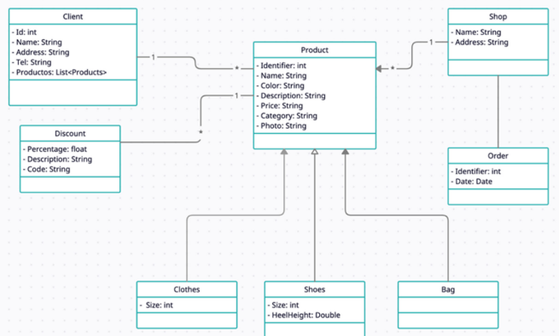
Module Description:
1: Experimental Design and Participant Management
This module designs and manages the family of experiments to compare the two tools. It handles participant registration, task assignment, and experimental setup in academic environments. It ensures controlled conditions for fair usability comparison.
2: Chatbot-Based Modeling System (SOCIO)
This module enables collaborative UML class diagram creation using a chatbot interface. Users interact through natural language to generate and modify diagrams. The system records interaction logs, task completion time, and user feedback.
3: Online Collaborative Modeling Tool Integration
This module provides access to a graphical web-based modeling tool similar to Creately. Participants build class diagrams using drag-and-drop features. The system tracks diagram completeness, conciseness, and task duration.
4: Usability and Performance Evaluation
This module measures usability metrics such as task completion time, diagram quality, and user satisfaction. It collects both quantitative and qualitative feedback from participants. Standard usability evaluation methods are applied.
5: Comparative Analysis and Research Insights
This module analyzes experimental results to compare both tools statistically. It identifies strengths and limitations of chatbot-based modeling. The module also provides recommendations and future research directions for collaborative diagramming.
Functional Requirements:
1. User (Participant) –
- User Login
The system shall allow participants to securely log in to access assigned modeling tasks.
- Task Participation
The system shall allow users to view and perform assigned class diagram modeling tasks.
- Chatbot-Based Modeling
The system shall allow users to create and modify UML class diagrams using the chatbot interface.
- Graphical Tool Modeling
The system shall allow users to create UML class diagrams using the graphical modeling tool.
- Diagram Submission
The system shall allow users to submit completed diagrams for evaluation.
- Feedback Submission
The system shall allow users to provide usability feedback and satisfaction ratings.
2. Admin (Researcher) –
- Admin Login
The system shall allow administrators to securely log in with privileged access.
- Participant Management
The system shall allow administrators to manage participants and assign experimental tasks.
- Experiment Configuration
The system shall allow administrators to configure experimental settings and tool assignments.
- Data Collection Management
The system shall store and manage diagram submissions, interaction logs, and task completion times.
- Usability Evaluation
The system shall allow administrators to evaluate performance metrics such as speed, diagram quality, and user satisfaction.
- Comparative Analysis & Reporting
The system shall allow administrators to perform statistical comparisons and generate experiment reports.

SYSTEM REQUIREMENTS:
HARDWARE REQUIREMENTS:
• System : Pentium IV 2.4 GHz.
• Hard Disk : 40 GB.
• Ram : 512 Mb.
SOFTWARE REQUIREMENTS:
• Operating system : - Windows.
• Coding Language : python.

